SOFTWARE REQUIREMENT

SYSTEM

FOR

STUDENT ATTENDANCE SYSTEM

PREPARED BY:-

PRADEESH.S

SRINATH.S

SANGAMAHESWARAN.P

**1.Introduction**

**1.1 Purpose**

The purpose of this document is to outline the software requirements for the development of an Attendance Tracking System. This system is designed to streamline attendance management for students, teachers, and courses in an educational institution. The system will provide a user-friendly interface for teachers to mark attendance and monitor student participation efficiently. This project describes the hardware and software interface requirements using ER diagram and UML diagrams.

**1.2 Document Conventions**

* Entire document should be justified.
* Convention for Main title
* Font face: Times New Roman
* Font Style: Bold
* Font Size: 14
* Convention of Sub title
  + - Font face: Times New Roman
    - Font Style: Bold
    - Font Size: 12
* Convention for body
  + - Font face: Times New Roman
    - Font Size: 12

**1.3 Scope of Development Project**

Student Attendance System is basically updating the manual attendance system or improving the already available online attendance system into live attendance system. The project includes the design of an intuitive user design with interactive dashboards for both teachers and students, ensuring accessibility across various devices.

Robust reporting and analytics features will be implemented to generate detailed attendance reports, enabling users to analyse the trends and patterns. Emphasizing data security and easy access to attendance records.

**1.4 Definitions, Acronyms and Abbreviations**

JAVA- platform independent

SQL-> Structured Query Language

ER-> Entity relationship

IDE-> Integrated Development Environment

UML-> Unified Modeling Language

SRS-> Software Requirement Specification

**1.5 References**

* ONLINE STUDENT ATTENDANCE MANAGEMENT SYSTEM G. Archana1 N. Mounika2 B. Siva Teja3 M. Navya 4, M. Hema Sai 5, Department of Computer Science Engineering, Vignan's Nirula Institute of Technology and Science for Women, Pedapalakaluru, AP, India.Corresponding Author mail id: [archu.gunakala@gmail.com](mailto:archu.gunakala@gmail.com)
* Student Attendance Management SystemKarwan Jacksi1*, Falah Ibrahim2, Shahab Ali3University of Zakho, Iraq Duhok Polytechnic University, Iraq University of Zakho, Iraq (2) (PDF) Student Attendance Management System. Available from: https://www.researchgate.net/publication/323511629_Student_Attendance_Management_System [accessed Dec 04 2023].
* Attendance management system project report. Retrieved from <https://www.slideshare.net/ManojKumar1530/attendance-management-system-project-report>

2. Overall Descriptions

2.1 Product Perspective

Use case diagram of student attendance system

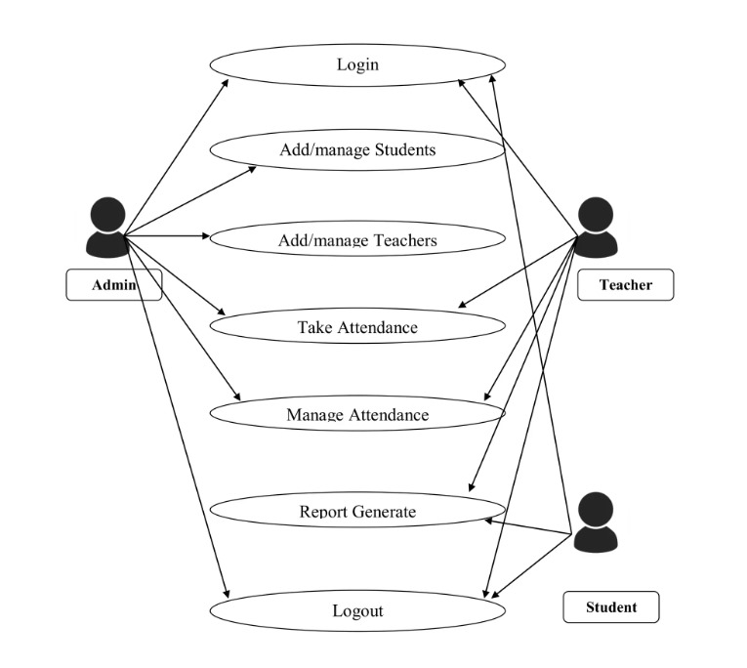

2.2 Product function

**2.3 User Classes and Characteristics**

The system provides different types of services based on the type of use[teacher/student]. The admin will be acting as the controller and they will have all the privileges of and administration. The member can be either student or staff of the university who will accessing the Attendance Management System.

The features that are available to the Teachers are:

* A teacher can mark attendance for students.
* Can view the report of individual student.
* Can send notifications about report to the parents and students.
* Can manage and approve leave request from the students.
* Teachers can manage the attendance based on timetable.
* Can make the graphical analysis on student academics.
* Seamless integration with class schedules
* Customization options based on class needs
* Generation of detailed attendance reports

The features that are available to the students are:

* Can access the personal attendance records
* Automated notifications for attendance status
* Viewing and downloading attendance reports
* Integration with individual class schedules
* Submission of leave requests for approval
* Accessibility from different devices
* User-friendly interface for easy interaction

**2.4 Operating Environment**

The product will be operating in windows environment. The Student Attendance System is a website and application and shall operate in all famous browsers and all mobile phones. The only requirement to use this online product would be the internet connection.

The hardware configuration includes : Hard Disk : 40GB,Ram:2GB,and the basic input devices required are keyboard, mouse and output devices are monitor and printer etc.

**2.5 Assumptions and Dependencies**

**The assumptions are:**

* The coding should be error free
* The system should be user-friendly so that it is easy to use for the users
* The information of all users, teachers and student must be stored in a database that is accessible by the website
* The system should have more storage capacity and provide fast access to the database
* The system should provide easy access and support quick transactions
* The attendance System is running 24 hours a day
* Users may access from any computer that has Internet browsing capabilities and an Internet connection
* Users must have their correct usernames and passwords to enter into their online accounts and do action

**The dependencies are:**

* The specific hardware and software due to which the product will be run
* On the basis of listing requirements and specification the project will be developed and run
* The end users (admin) should have proper understanding of the product
* The system should have the general report stored
* The information of all the users must be stored in a database that is accessible by the Attendance System
* Any update regarding the Student from the Teacher is to be recorded to the database and the data entered should be correct

**2.6 Requirement:**

Software Configuration:

This software package is developed using java as front end which is supported by sun micro system. Microsoft SQL Server as the back end to store the database.

Operating System: Windows NT, windows 98, Windows XP

Language: Java Runtime Environment, Net beans 7.0.1 (front end)

Database: MS SQL Server (back end)

Hardware Configuration:

Processor: Pentium(R)Dual-core CPU

Hard Disk: 40GB

RAM: 256 MB or more

2.7 Data Requirement:

The inputs consist of the query to the database and the output consists of the solutions for the query. The output also includes the user receiving the details of their accounts. In this project the inputs will be the queries as fired by the users like create an account, selecting options and accessing into account. Now the output will be visible when the user requests the server to get details of their account in the form of record of attendance which are currently in the account.

**3. External Interface Requirement**

**3.1 GUI:**

The GUI for both teacher and student interfaces prioritizes user-friendliness, efficiency, and accessibility, contributing to a positive user experience within the Attendance Tracking System.

3.1 Teacher Interface:

The Teacher Interface is designed to provide an intuitive and efficient experience for educators in managing attendance and related tasks.

**3.1.1 Login Screen:**

The system begins with a secure login screen where teachers input their credentials. - Username and password fields are provided for authentication.

**3.1.2 Dashboard:**

Upon successful login, teachers are directed to a dashboard displaying relevant information. - Widgets on the dashboard include quick links to mark attendance, view reports, manage leave requests, and send notifications. - Graphical representations of attendance trends may be displayed for quick analysis.

**3.1.3 Attendance Marking:**

A dedicated section for marking attendance, allowing teachers to select the class and quickly mark the attendance of students. - Options to mark attendance based on a timetable or manually.

**3.1.4 Student Reports:**

A feature enabling teachers to view detailed reports for individual students. - Graphical representations of attendance history and academic performance.

**3.1.5 Leave Management:**

Interface for managing and approving leave requests from students. - Notifications for pending leave requests.

**3.1.6 Notifications:**

Teachers can send notifications about attendance reports to parents and students directly from the interface. - Options to customize and schedule notifications.

**3.1.7 Settings:**

Personalized settings for teachers, allowing customization of interface preferences. - Option to integrate with class schedules seamlessly.

**3.2 Student Interface:**

The Student Interface is designed to provide students with easy access to their attendance records and related features.

**3.2.1 Login Screen:**

Secure login screen with username and password fields for student authentication.

**3.2.2 Dashboard:**

A user-friendly dashboard displaying personal attendance records, notifications, and leave request status. - Quick links to view and download attendance reports.

**3.2.3 Attendance Records:**

Detailed view of individual attendance records, including graphical representations. Automated notifications for attendance status.

**3.2.4 Leave Requests:**

Interface for submitting leave requests with status tracking. - Notifications for approval or rejection of leave requests.

**3.2.5 Settings:**

Personalized settings for students to manage notification preferences. - Accessibility from different devices, ensuring a responsive design.

**4. System Features**

The users of the system should be provided the safety that their account is secure. And manage leading options.

* User authentication and validation using their unique member ID
* Proper monitoring by the administrator which includes updating account status, User roles and permissions management to control access levels.
* Quick access to system-wide statistics, user activity, and alerts.
* Robust security measures to protect sensitive attendance data.
* Detailed logs capturing user activities within the system.

**5.Other Non-functional Requirements**

**5.1 Performance Requirement**

* The system should support concurrent access by at least 500 users without degradation in performance.
* Attendance data retrieval should take no more than 3 seconds.
* The system should have an uptime of at least 99.9% for availability.

**5.2 Safety Requirement**

The system should have automated data backup procedures to ensure data safety. In the event of a system failure, there should be a recovery process in place to restore data. The system should have failover mechanisms to minimize downtime.

**5.3 Security Requirement**

* User authentication must use strong encryption methods.
* Access control measures should be in place to restrict unauthorized access to sensitive data.
* The system should comply with relevant data protection regulations.

**5.4 Requirement attributes**

* **All requirements should be traceable to specific system features and functionalities**
* Each requirement should be assigned a priority level (high, medium, low) based on its importance.
* Requirements should be clearly documented with acceptance criteria for verification.

**5.5 Business Rules:**

A business rule is anything that captures and implements business policies and practices. A rule can enforce business policy, make a decision, or infer new data from existing data. this includes the rules and regulations that the System users should abide by. This includes the cost of the project and the discount offers provided. The users should avoid illegal rules and protocols. Neither admin nor member should cross the rules and regulations.

**5.6 User Requirement:**

The users of the system are Students, teachers and admin of the university who act as administrator to maintain the system. The members are assumed to have basic knowledge of the computers and internet browsing. The administrators of the system should have more knowledge of the internals of the system and is able to rectify the small problems that may arise due to disk crashes, power failures and other catastrophes to maintain the system. The proper user interface, user manual, online help and the guide to install and maintain the system must be sufficient to educate the users on how to use the system without any problems.

The admin provides certain facilities to the user in the form of :

* Password reset and account recovery functionalities are available.
* Data migration
* Data replication
* Auto recovery
* Maintaining files
* The server must be maintained regularly and I has to be updated from time to time.

**6. Other Requirements**

**6.1 Data and category requirement**

There are different categories of users namely teaching staff, Admin, students etc. Depending upon the category of user the access rights are decided. It means if the user is an administrator then he can be able to modify the data, delete, append etc. All other users except the Administrator only have the rights to retrieve the information about database. Similarly there will be different categories of options available. According to the categories of users their relevant data should be displayed. The categories and the data related to each category should be coded in the particular format.

**6.2 Appendix**

1. Admin, Abbreviation, Acronym, Assumptions; B: Books, Business rules; C: Class, Client, Conventions; D: Data requirement, Dependencies; G: GUI; K: Key; L: Library, Librarian; M:

Member; N:Non-functionalRequirement; O:Operatingenvironment;

P:Performance, Perspective, Purpose; R: Requirement, Requirement attributes; S: Safety, Scope, Security, System features; U: User, User class and characteristics, User requirement;

**6.3 Glossary**

The following are the list of conventions and acronyms used in this document and the project as well:

6.3 Glossary

* The following are the list of conventions and acronyms used in this document and the project as well:
* Administrator: A login id representing a user with user administration privileges to the software
* User: A general login id assigned to most users
* Client: Intended users for the software
* SQL: Structured Query Language; used to retrieve information from a database
* SQL Server: A server used to store data in an organized format
* Layer: Represents a section of the project
* User Interface Layer: The section of the assignment referring to what the user interacts with directly
* Application Logic Layer: The section of the assignment referring to the Web Server. This is where all computations are completed
* Data Storage Layer: The section of the assignment referring to where all data is recorded
* Use Case: A broad level diagram of the project showing a basic overview
* Class diagram: It is a type of static structure diagram that describes the structure of a system by showing the system’s cases, their attributes, and the relationships between the classes
* Interface: Something used to communicate across different mediums
* Unique Key: Used to differentiate entries in a database

**6.4 Class Diagram**

A class is an abstract, user-defined description of a type of data. It identifies the attributes of the data and the operations that can be performed on instances (i.e. objects) of the data. A class of data has a name, a set of attributes that describes its characteristics, and a set of operations that can be performed on the objects of that class. The classes’ structure and their relationships to each other frozen in time represent the static model. In this project there are certain main classes which are related to other classes required for their working. There are different kinds of relationships between the classes as shown in the diagram like normal association, aggregation, and generalization. The relationships are depicted using a role name and multiplicities. Here ‘Librarian’, ‘Member’ and ‘Books’ are the most important classes which are related to other classes.

